Escape the Maze

**Lab Description :** You will be given a 2D matrix of chars that contains three different symbols: an asterisk, a space, or a dot. The dot is your starting point, and will be located at the position (4,3) – just like the parameters of your constructor.

Your job is to create a recursive solution to move from (4,3) to an “escape” of the maze, which is simply a space on the outside edge of the maze. Consider all of the asterisks as “walls” that you can not travel through. Therefore, you must walk along the corridors to see IF there is an exit. If there is no exit to the maze, then your recursion should report that *only after exhausting all possibilities*. Warning: though loops are involved in the solution, an iterative solution will not be accepted.

**Example Maze**

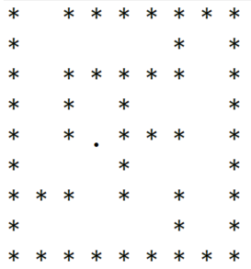

**The solution to this maze is at (0,1)**

**Extention 1:**

Show the fewest number of steps it takes to get from your starting point to the exit.

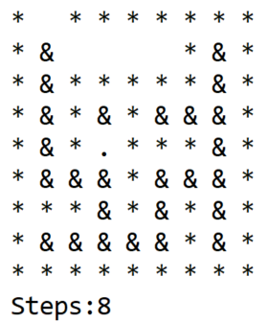

**Extention 2:**

Design a display that will show the recursive steps taken one-by-one, as if in an animation (though clearly just a redraw of the maze multiple times). Your teacher will show you an example of how it can appear